Burlington Day 5K sponsored by Third State Brewing

Race Day is just ahead! 🙂 Here is some information which will help make your day amazing!

*Please Note: This event is Rain or Shine. The Brewery may ID check if they choose before serving beer. So have ID available incase needed.

Race Starts at 10am on May 20th.

The start line is located at 201 High Street, Burlington, NJ 08016.

1. We strongly encourage as many runners as possible to take advantage of the pre-race day packet pick up option on Friday (May 19) from 6-9pm at Third Sate Brewing located at 352 High Street, Burlington. Please note, runners may pick up for others.

2. The 5K souvenir pint glasses will be distributed to all runners at Third State Brewing.

3. Legend’s Pizza will be at the finish line sponsoring our post-race food for your enjoyment after the run!

4. The run will be chip timed and chips will be located on your race bibs. Please wear bib on front exterior clothing item as that ensures the best read from antennas.

AWARDS: All awards are based on gun time so please seed yourselves accordingly. Thank you. Age Group Awards are: under 14, 15-19, 20-29, 30-39, 40-49, 50-59, 60-69 and over 70.
- Awards will be presented at approximately 11:15am at Third State Brewing.

5. Results may be found a variety of ways. Any questions regarding the results may be directly handled by the timer for quickest response. cisellers@verizon.net
- There will be a computer kiosk near the finish line where runners can check their results.
- Results will be posted on line https://runsignup.com/race/results/?raceId=43529 and emailed to you.
- Many of you will be text messaged the results.

6. There will be plenty of parking in designated parking areas that are located off of High Street – however carpooling, as always, is recommended! Also, runners can take the River Line Train to Burlington Center City and walk a couple of blocks to the start line.

7. Course Map: (Course will be well marked and volunteers directing at important turns, Police will be controlling traffic on roads for your safety)
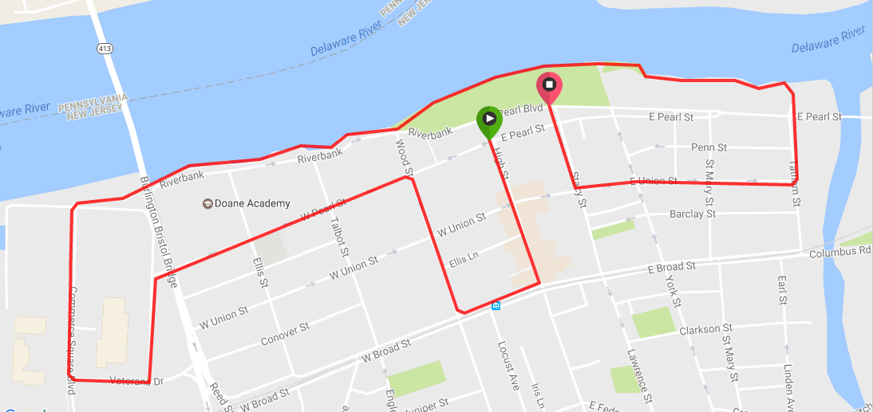

8. We will have a water station near mile 1.5 plus one at finish line.

9. There will be some porta potties on the Riverfront Promenade. In addition, Brick Wall Tavern and Third State Brewing which are located near the starting line will make their bathrooms available to the runners before the race.

10. Two Photographers will be on site taking photos. After the race, you can find the FREE downloadable photos at www.StinsmanPhotographyllc.pixieset.com/burlingtonday5k/
Download pin: 9249 Also photos can be viewed on our Facebook page https://www.facebook.com/burlingtonrunningclub/

11. Guests are welcome to come and cheer and if they would like a souvenir pint glass they can be purchased at Third State Brewing after the race for $5.00

12. Plan to spend the day in Burlington! Burlington Day begins at noon at the River Front Promenade where there will be games for the children, food trucks, crafts and more. In addition, Third State Brewing will be having live music at 3pm and 6pm. Many of the local restaurants like Legends Pizza and Tap and Brick Wall will be offering discounts to runners and their families on race day!

13. Our race is almost sold out! Swag is guaranteed for all who pre-registered by Saturday May 13. Registration is available at Packet Pick-Up on Friday night and on race day. No Transfers or Refunds are permitted.

14. No dogs are permitted on the course. Strollers are welcome. We ask that all runners/ walkers that are coming with a stroller please line up towards the back of the line for safety purposes.

We look forward to seeing you all on Saturday!! It is going to be a fun-filled day!

Sincerely,
Aisha O’Donnell

